Shutdown FELIX
Shutdown FELIX
- Go to the control room to the FELIX operating post.
- Turn off the GUN RF TIMING ON button, turn the BEAMLOSS knob to Normal mode, Switch off 3GHZ RF TIMING ON, GUN HV ON, GUN RF ENABLE, 3 GHZ ENABLE, CHARGE MODULATOR and SLINGERCIRCUIT ON. 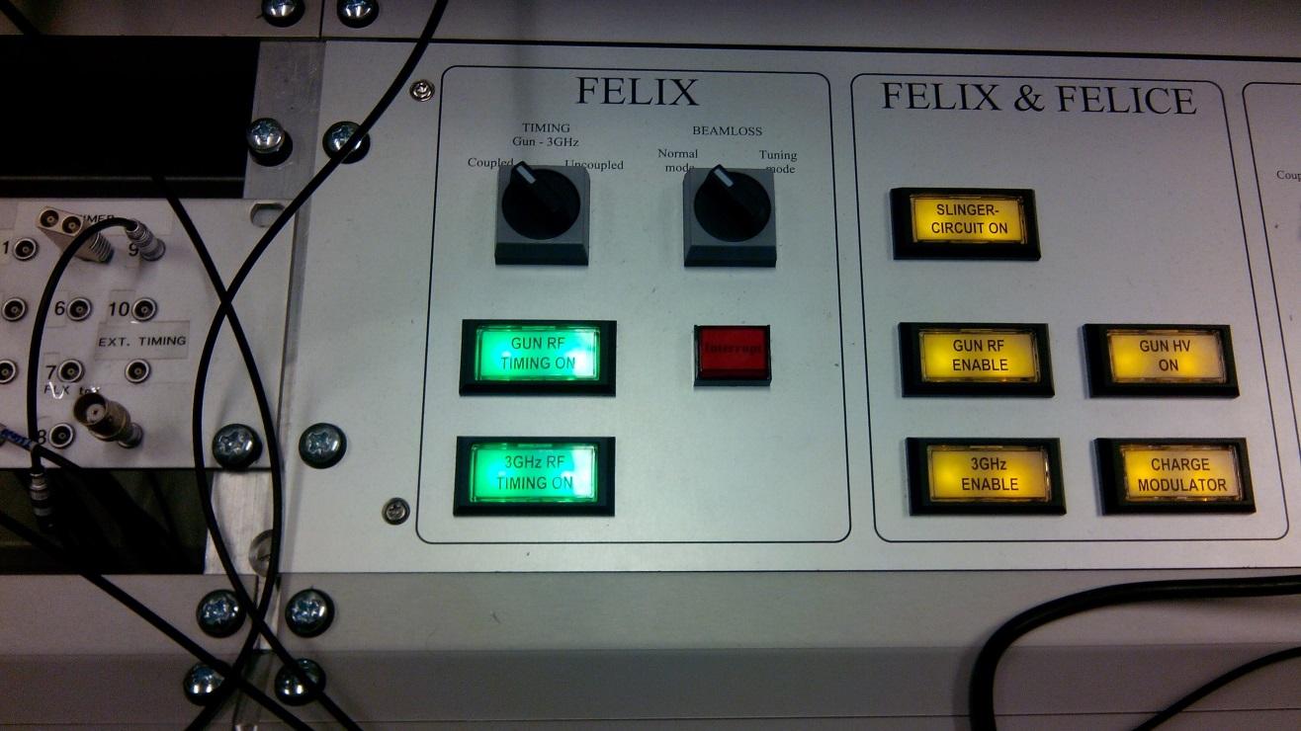
2b
2e
2f
2g
2h
2d
2c
2a

- Turn off all the Feedback buttons.
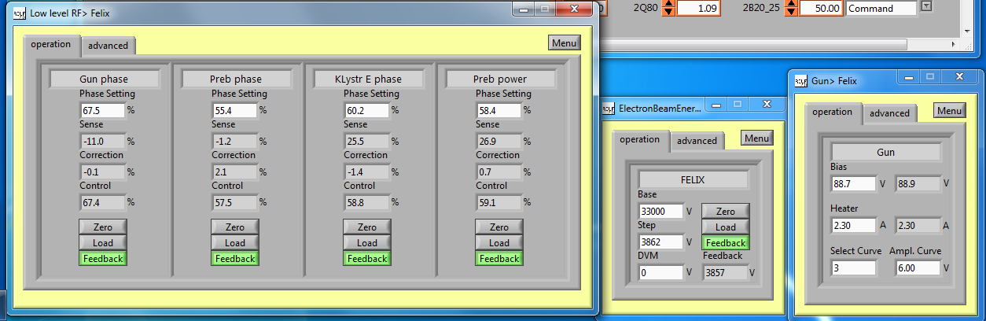
3

- Next is to turn off the dipoles via the controlroom PC. Search for the program FELIX dump line L2.Click on the arrow near the command box and chose: Mains power off.
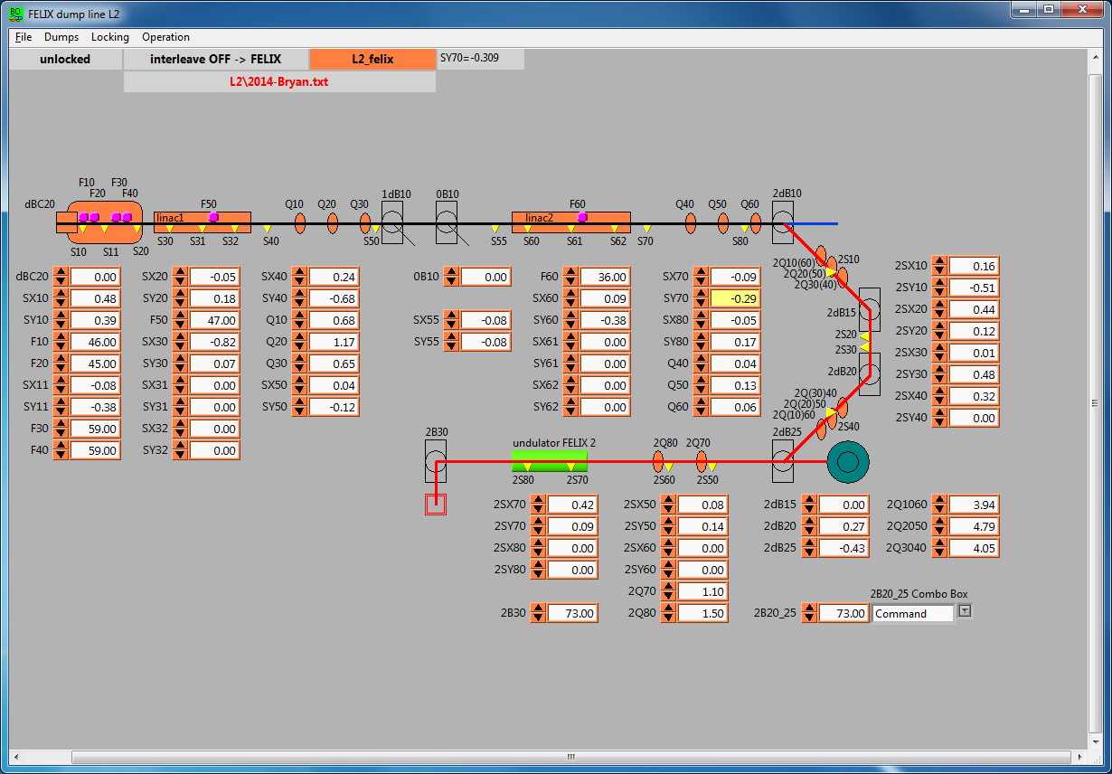
4

- Next is to close all vacuum valves by pressing the close all valves button in the Vacuum Control Gui.
5
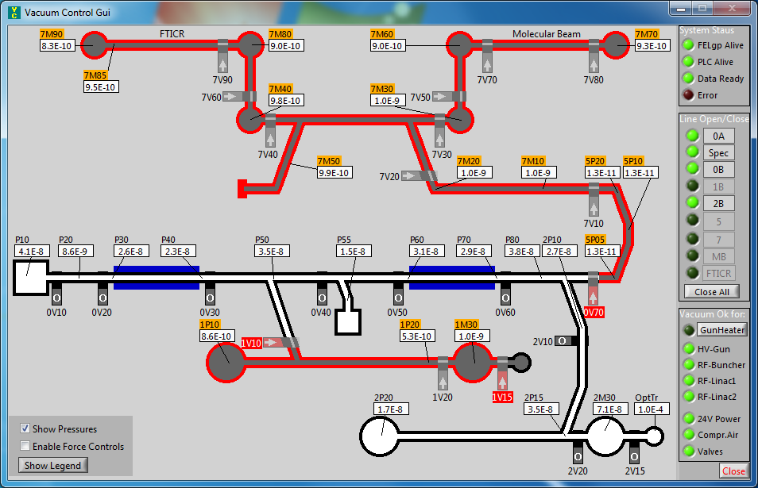
- Next is to reopen valve 2V20 again by clicking it.
- The next step is to make shorter pulses in the timing system gui. By making it 2.00 us and pushing Ok afterwards.
7b
7a
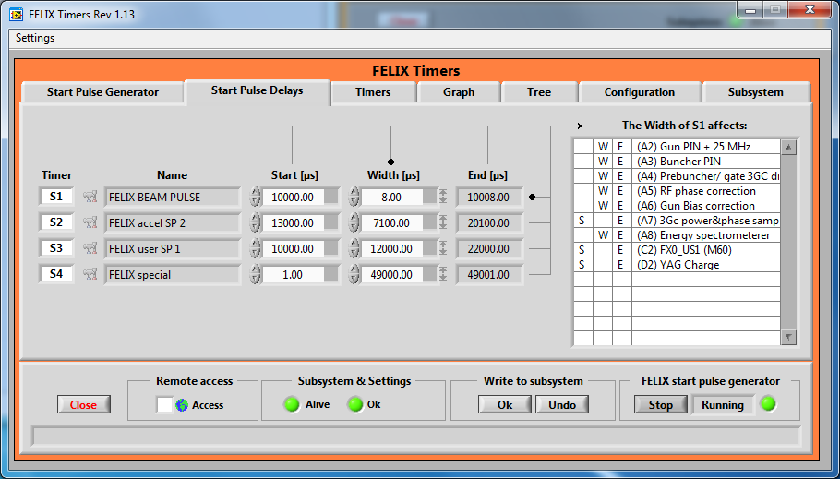

- Now it is time to decrease the repetition rate of FELIX on the tab Start Pulse generator, put the clock divider to 10 and push Ok again.
8b
8a
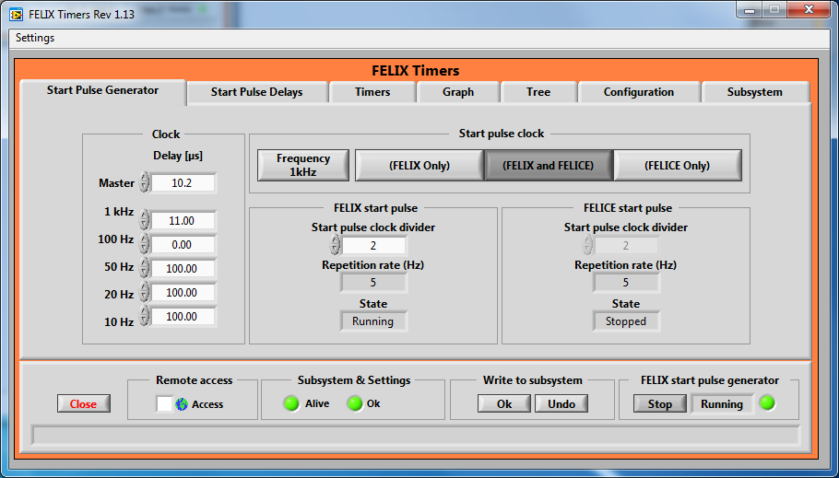
- The next step is to check if the RSS is in <Restricted access> if not put it in the correct access mode. Head downstairs into the FEL Technical area, and go to the modulators cabinets, which are located near the FELIX klystrons.
- Next is to turn off the RF amplifier from the WEST modulator. It is hanging on the left wall when you enter the FEL Technical Area.
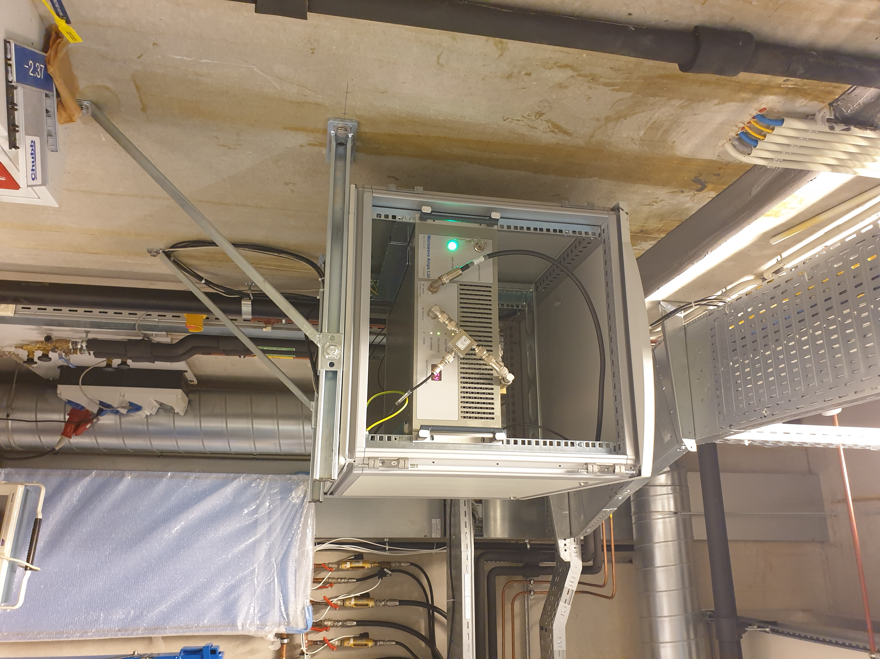
10

11
- Put the 2 modulators into local control by pushing the red local button.
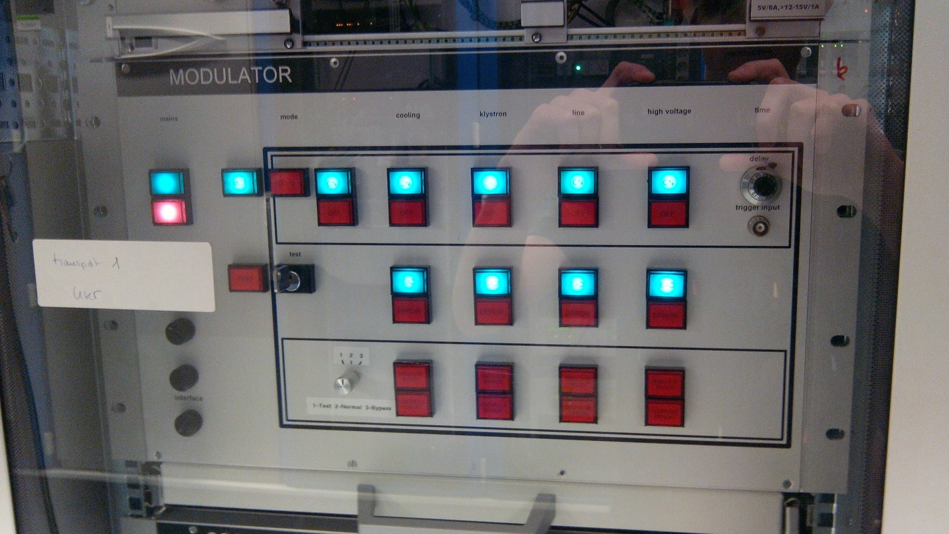
12c
12e
12d
12b
12a
- Next when the controlmode is set to local control is to switch of the following parts in that order: high voltage, line, klystron, cooling and mode by pushing the buttons.
- Next turn off the 4 high voltage power supplies which are located next to the klystrons. Use the main switch not the key
12
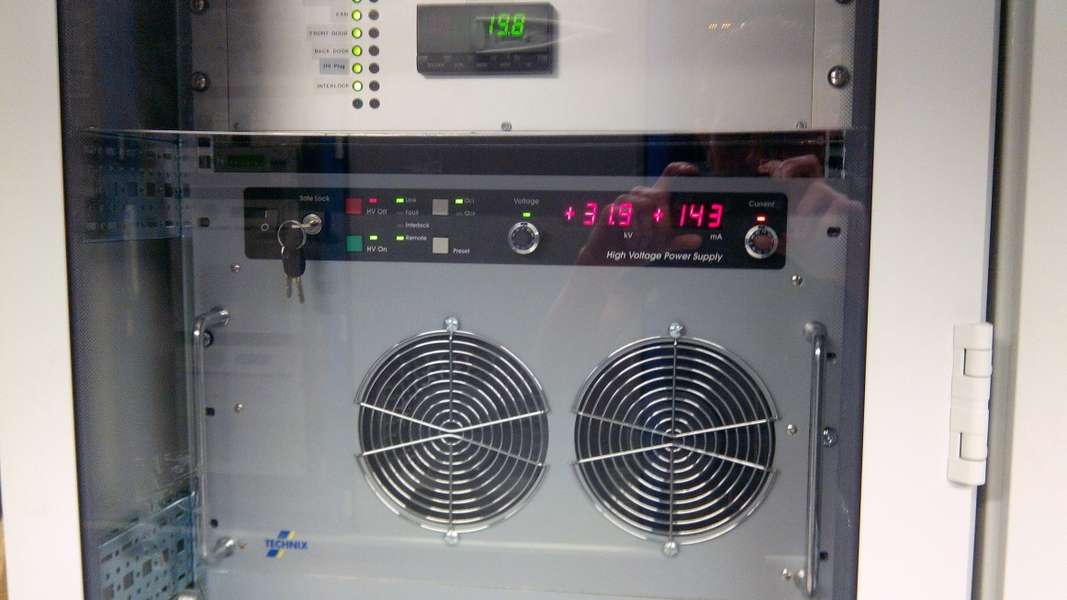
- As next step it is time to turn off the RF amplifier and Gun High voltage power supply, which are located at the right backside of the FELIX klystron, turn off the green amplifier enable button, and turn off the high voltage power supply.
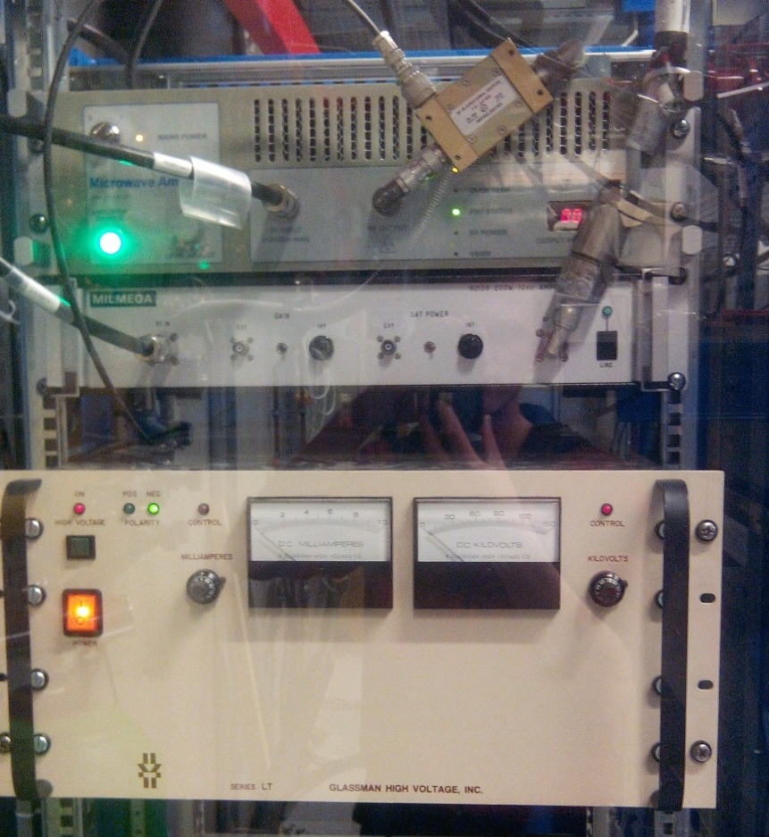
13b
13a

- As next step the cavity amplifier has to be shut off, this is done with the COFFEE interface. It can be turned of by pushing the Prebuncher OFF button. IMPORTANT: LEAVE COFFEE ON, or it will not wake up FELIX the next morning!
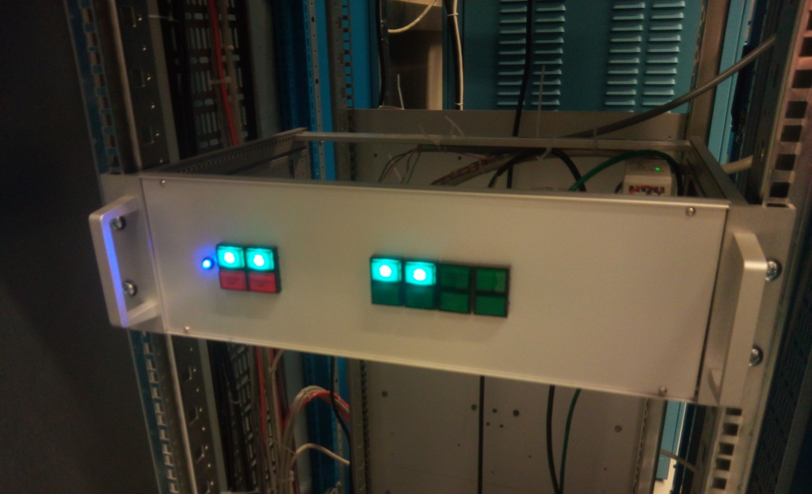
14
IF FLARE is running proceed to step 23.
As last and final step is to put off the power supplies of the electronics cabinets, this panel is located at the entrance of the FEL technical area, next to the electronics corridor, turn off all the green buttons. Be sure FLARE isn’t running, because this action will pull away the FLARE electron beam.
- Next turn off all the cabinets of FELIX, by turning all the green lights off.
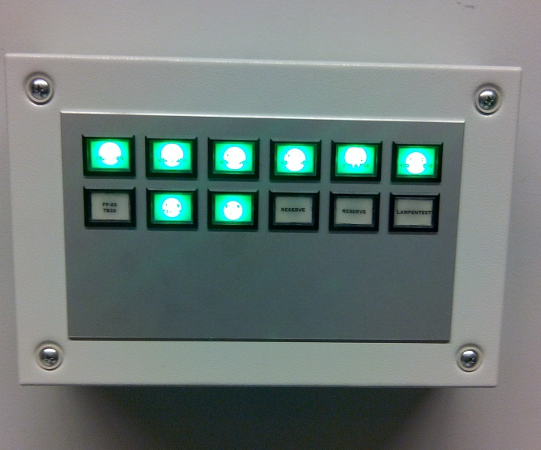
15

- Go to the FLARE Console and click on the [Shortcuts control…. Folder]
16
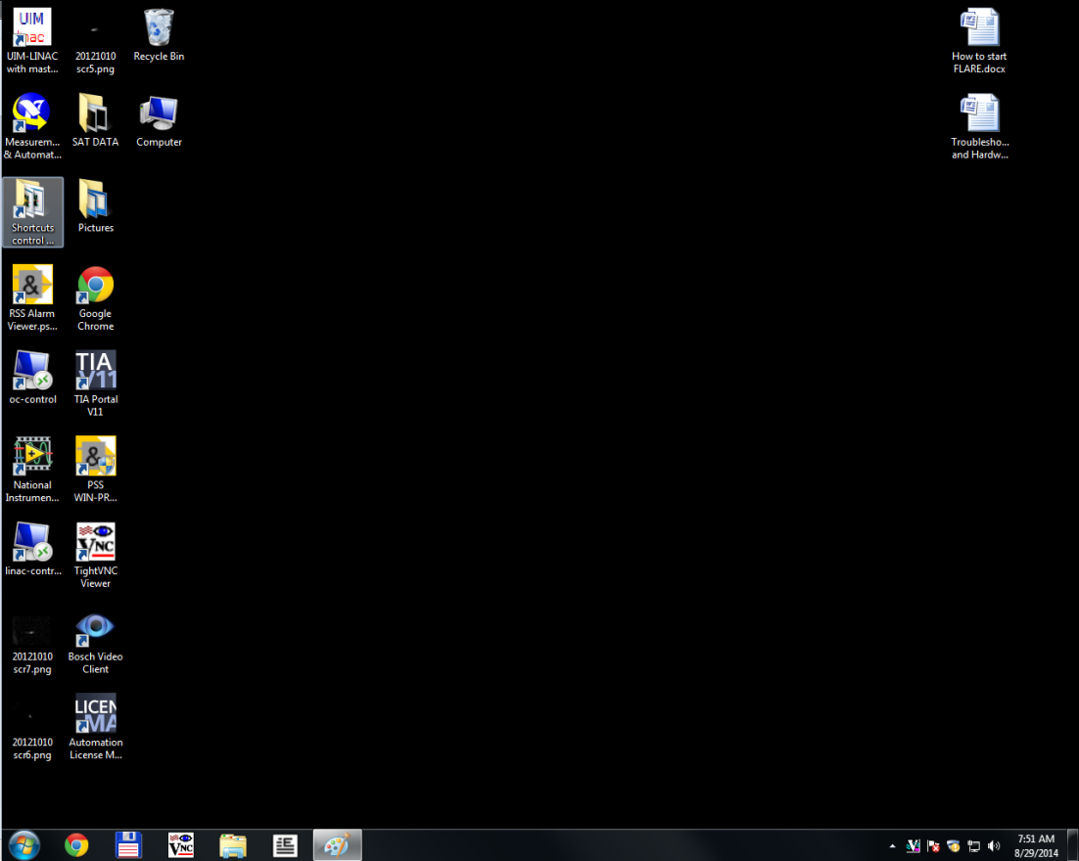
16
- Now it opens the screen below, from this directory select the directory new controls 2017.
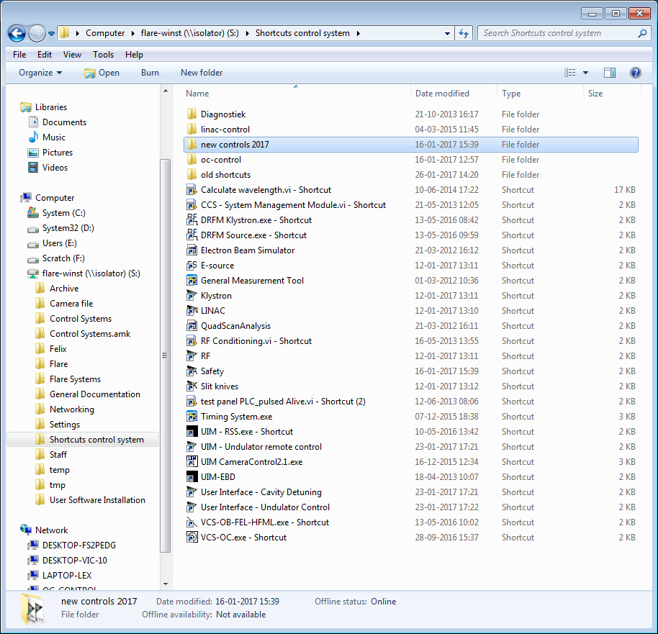
17

- Run the program LINAC.
18
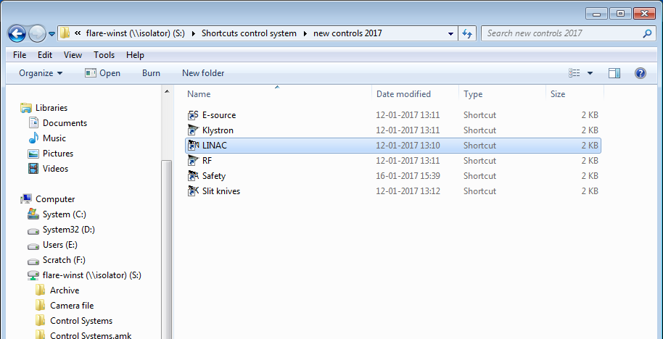

- It will open the FLARE LINAC control program, next is to request master operator status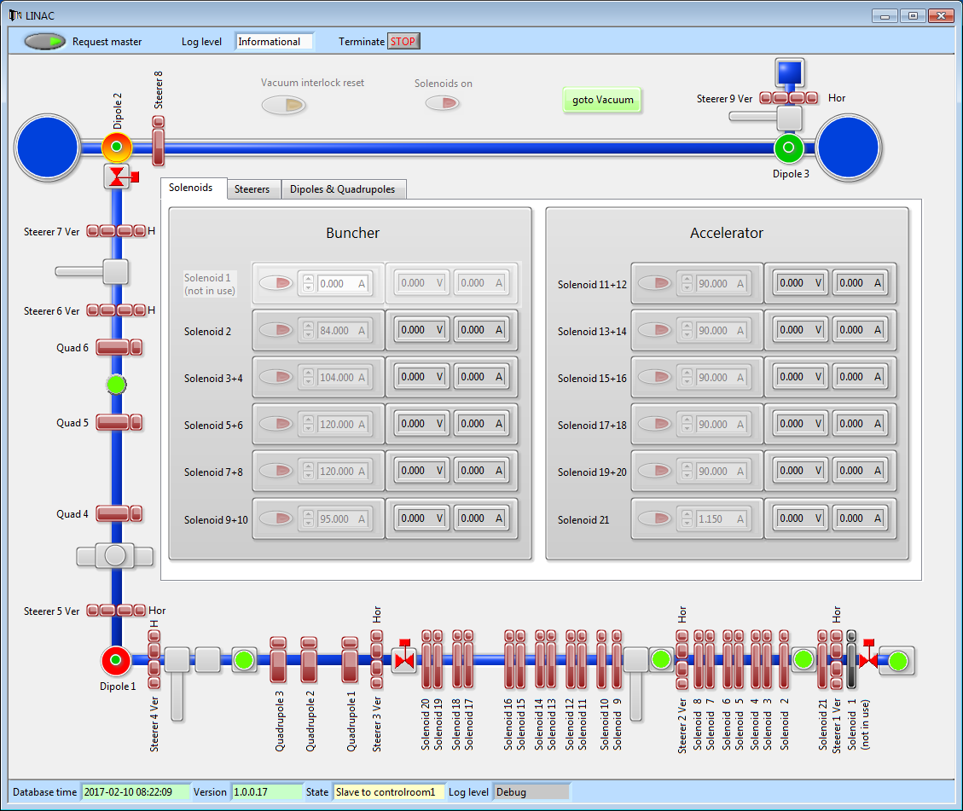
19
- For some magical reasons when the program is running for a longer time it might happen that it is bugged and no longer master operator this can be seen when it signals slave to controlroom1 as seen above. A fix for this is to just release and request master operator again.
6

- When the master operator status has been granted the solenoids can be turned off by pushing the Solenoids on button.
21
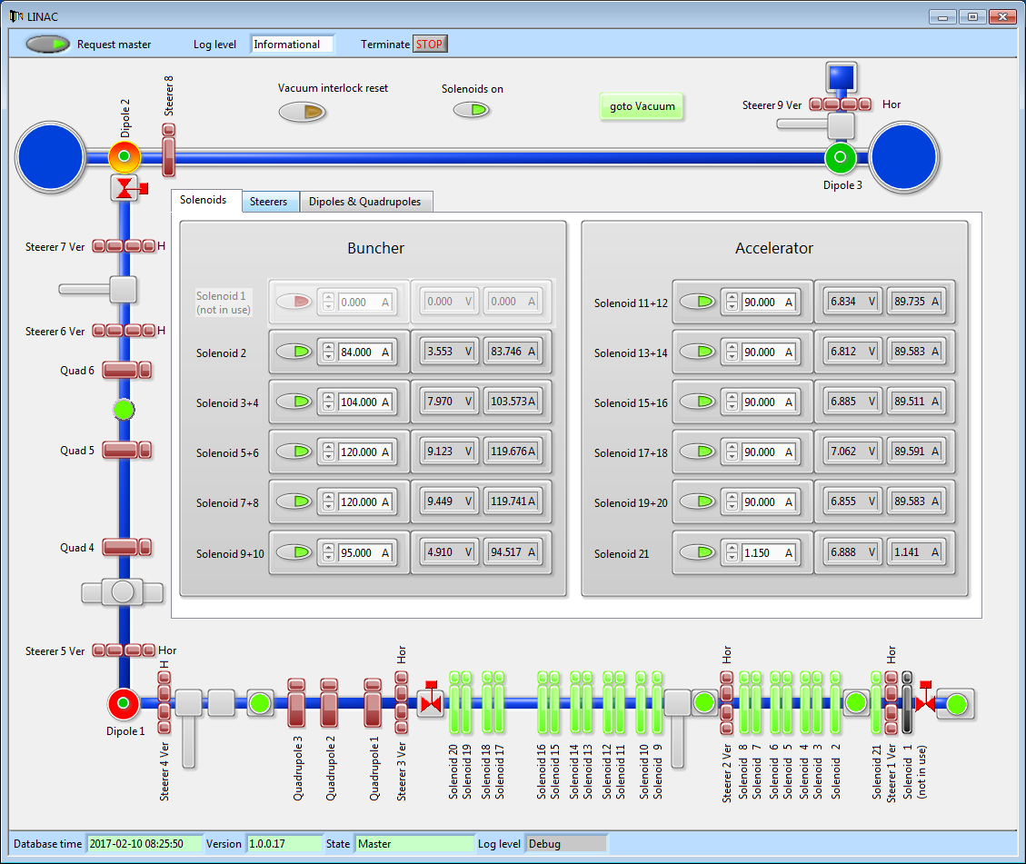
- If the solenoids are off they will turn red.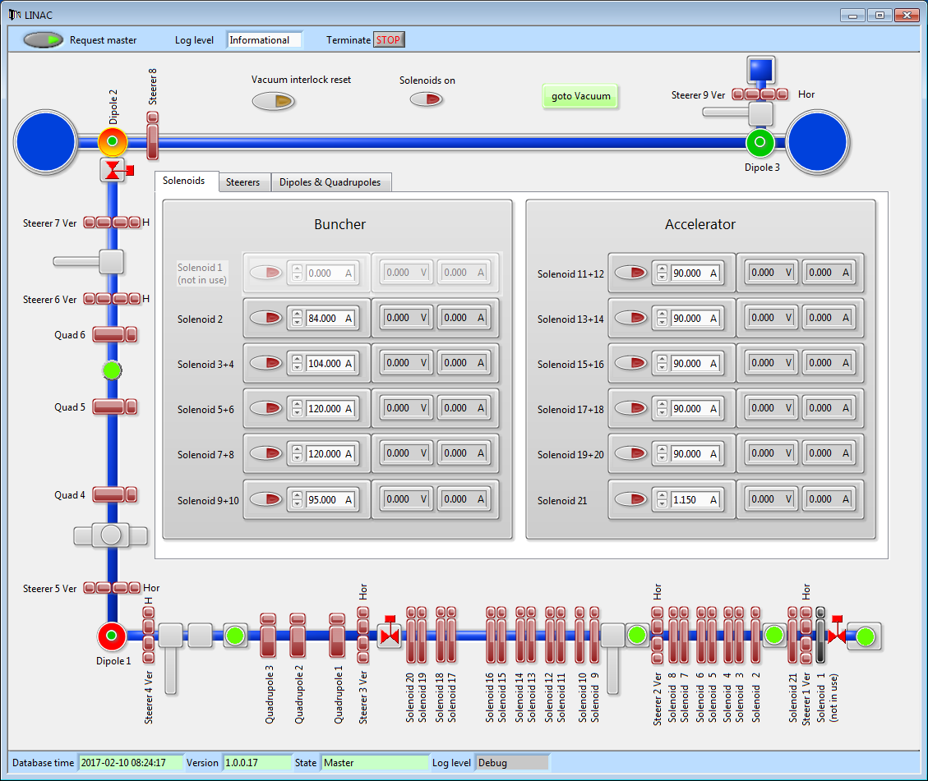

- Last step is to turn the Masterkey from RUN to SWEEP.
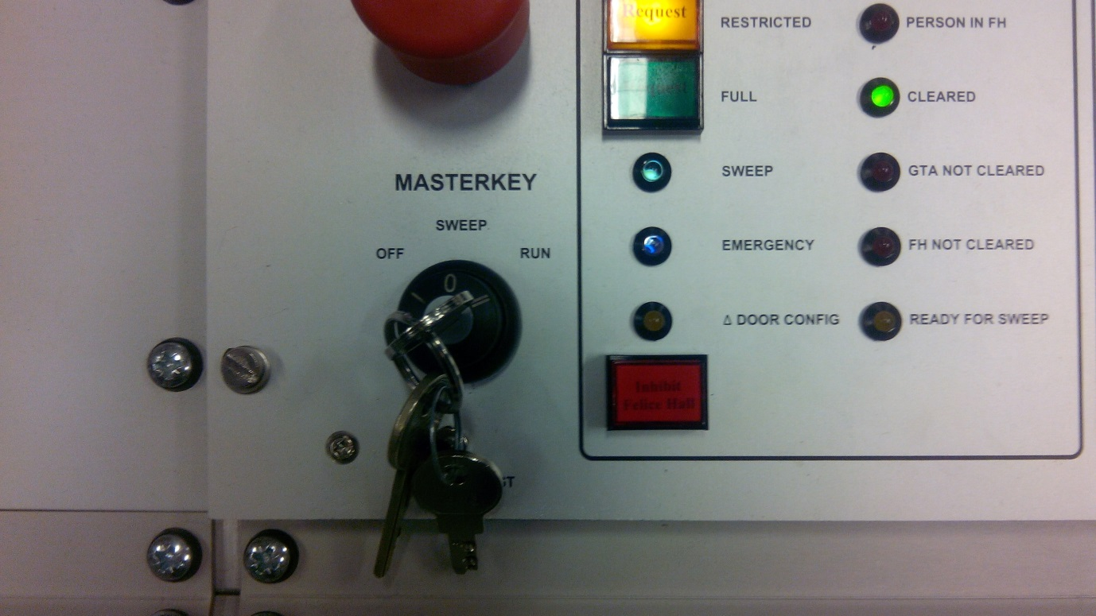
23

- Shutting down has now been completed.

