Setting up FELIX – Quick guide
- Switch on all 5 “FELIX & FELICE” buttons on main panel
- Select the correct user station / 25MHz or 1GHz mode
- Find/load a previous dump-line setting for E-range
- Find/load same setting in low-level RF phases
- Change current in “magneetslingercircuit” to match 2B20_25.
- Change “Gun bias” to ∼170.5 V (25MHz) / ∼80 V (1GHz). Precise number should be in the file name.
- Check the file has correctly loaded in the HPRF window. Set HPRF values to match the yellow targets
- Switch the “3GHz RF timing on” button on main panel
- Set klystron modulators to target values (from file name). Step is ∼4kV - 5kV. Press ‘feedback’ off, and ‘zero’.
- If FLARE solenoids are off, switch them on.
- In low-level RF power boxes, press ‘feedback’ off, and ‘zero’ all.
- Check timer S1 = 2µs and rep. rate = 1Hz. Open vacuum system.
- Insert BS, and align cavity mirrors. Watch 2S21, align downstream. Watch 2S41, align upstream. Remove BS.
- Press ‘GUN RF timing on’ on main panel.
- Optimize e⁻ path. Align with indicator. PM10 = SX10. PM20 = SX11. PM30 = SX30* (fault with blue, align 1 square below indicator). PM40 = SX40. PM50 = SX55. PM60 = SX70. Slowly ramp to ∼10µs / 10Hz, ensure all e⁻ are dumped.
- Fine-tune low level RF phases. Once done, press ‘zero’, ‘load’, and ‘feedback on’ in all. At diagnostic station, switch amplifier to x1 (@1GHz) or x10 (@25MHz).
- Adjust gun bias to achieve 360mV @25MHz / 200mV @1GHz (yellow curve on scope)
- Find cavity zero. Set ‘dt_CLdetuning’ to zero, and adjust “DT_CLzero” close to an unstable state. Then, reset ‘dt_CLdetuning’ to 1.8.
- Calibrate λ. Go to calc, and set lambda to correct live value.
Detailed notes: setting up FELIX (FEL-2)
- Turn the key from “standby” to “run”. Switch on all 5 main buttons for FELIX (assuming all machines have been turned on).
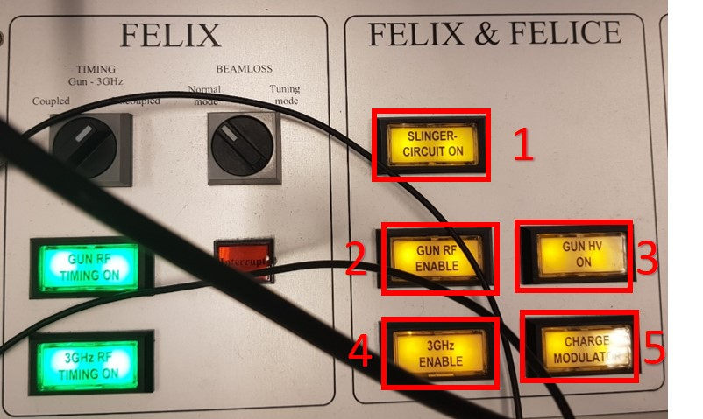

- In the window “FELIX User Station”, choose the user station / if 25 MHz is being used [Note: in these instructions, I assume that 25 MHz is indeed being used].
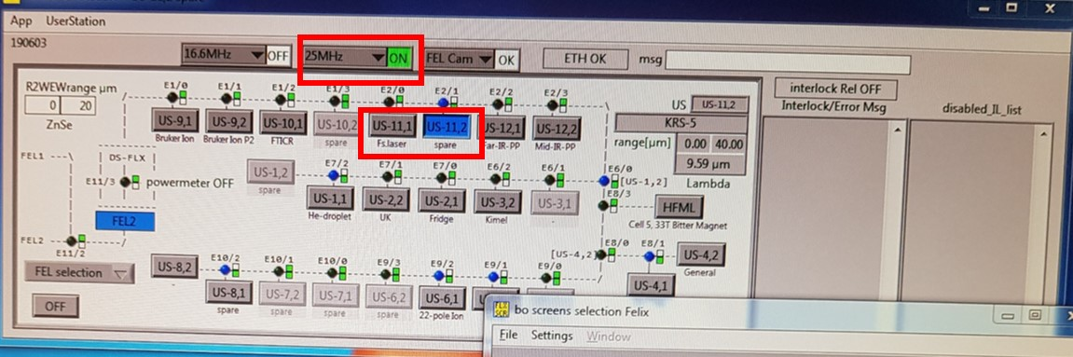

- Set the beam energy in MeV. In the window “uc_flx_gui”, go to “calc”, “enter” and “move”. Set “Mean Gap” to 35 mm (this makes the lasing easier to find at first). Common ranges are:
RF Power (MeV) | λ_{min} (µm) | λ_{max} (µm) | 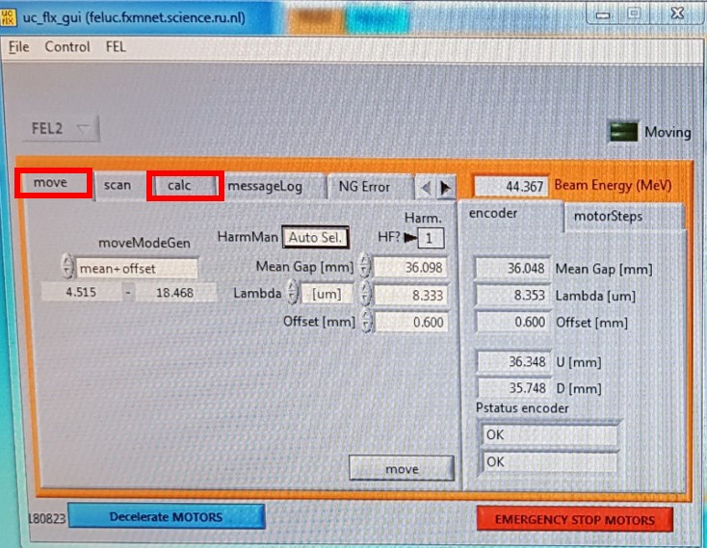
27.5 | 13.1 | 50
30 | 11 | 42
31.4 | 10.1 | 38.5
38 | 6.9 | 26.3
44 | 5.5 | 19.6
45.5 | 5 | 18.3
47 | 4.8 | 17

- In the window “FELIX_dump_line_L2”, find a previous (and most recent) setting for the same beam energy / rep rate. (1) Open “File”, “Find setting”, “load”. The suitable file name should then appear (2). Then “unlock” the panel.
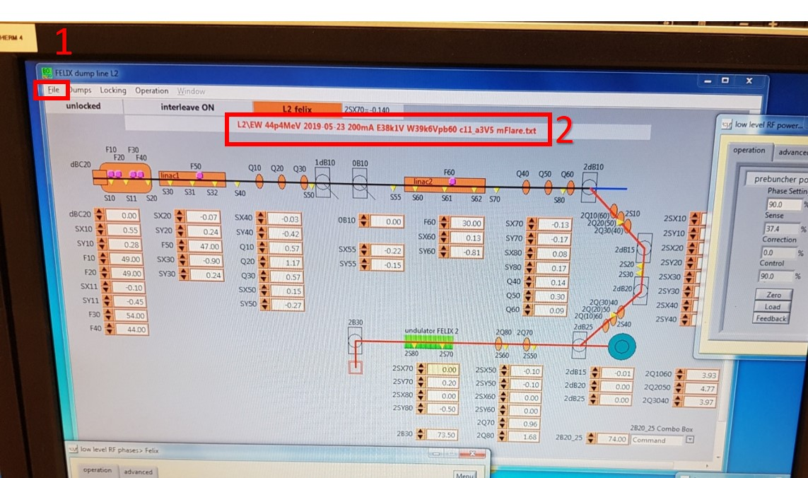

- In the window “Gun > Felix”, change the gun bias to ∼76 V (for 1GHz) and ∼170.5V (for 25MHz). This value is often noted in the filename…
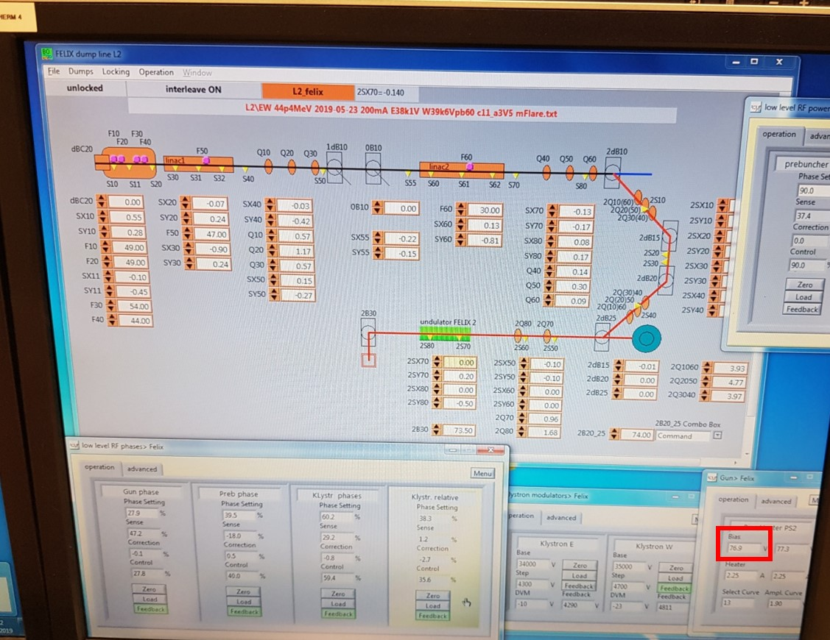
- In the window “Magneetslingercircuit”, change the current to match the value shown in “2B20_25”.
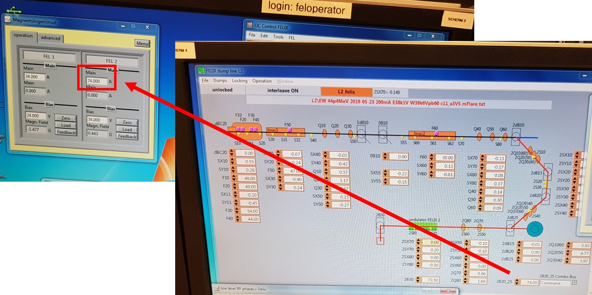

- In the window “low level RF phases > Felix”, right-click the menu box, “open”, and “load” the corresponding 25 MHz setting. This must be identical to the file loaded earlier.
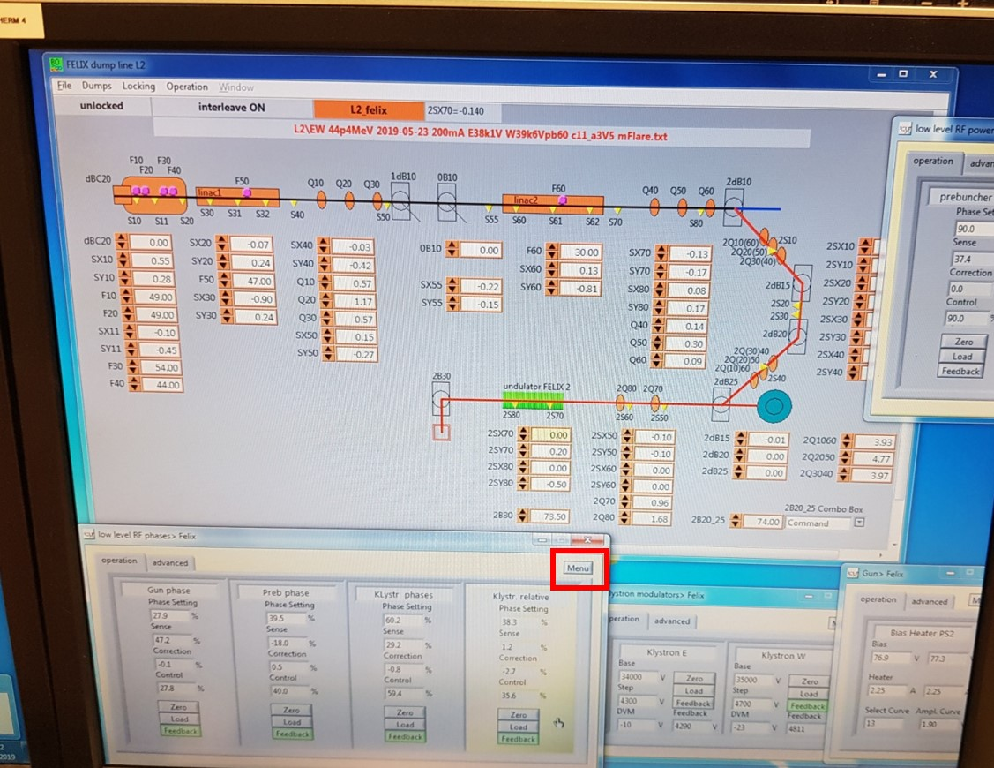
- In the window “HPRF.vi”, double-check the file has been loaded. Set the boxes to the loaded yellow target values. Then, switch on the button “3GHz RF timing on”.
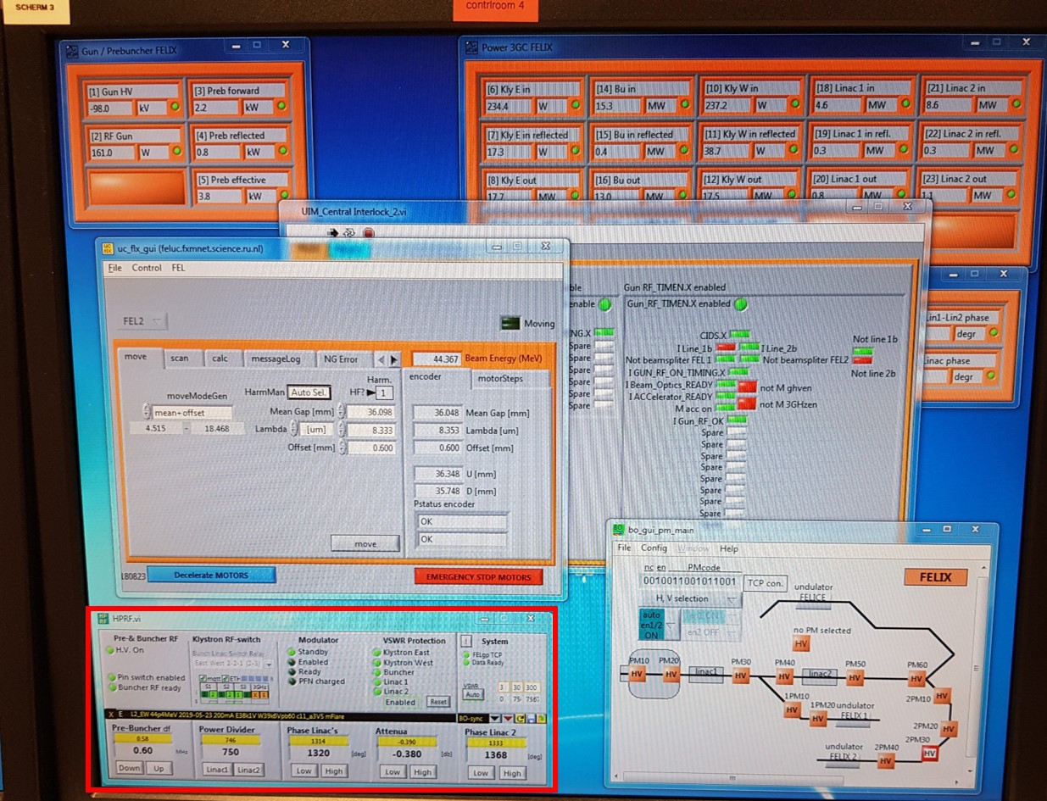
- Set the klystron modulators so they reach the target value (specified in the file name, with the line “E38k1V W39k6V”). Set the step to about 4k – 5k, and the base to the corresponding required level. Press “feedback” off, and “zero”. In the low-level RF power boxes, switch all “feedback” buttons off, and press “zero”.
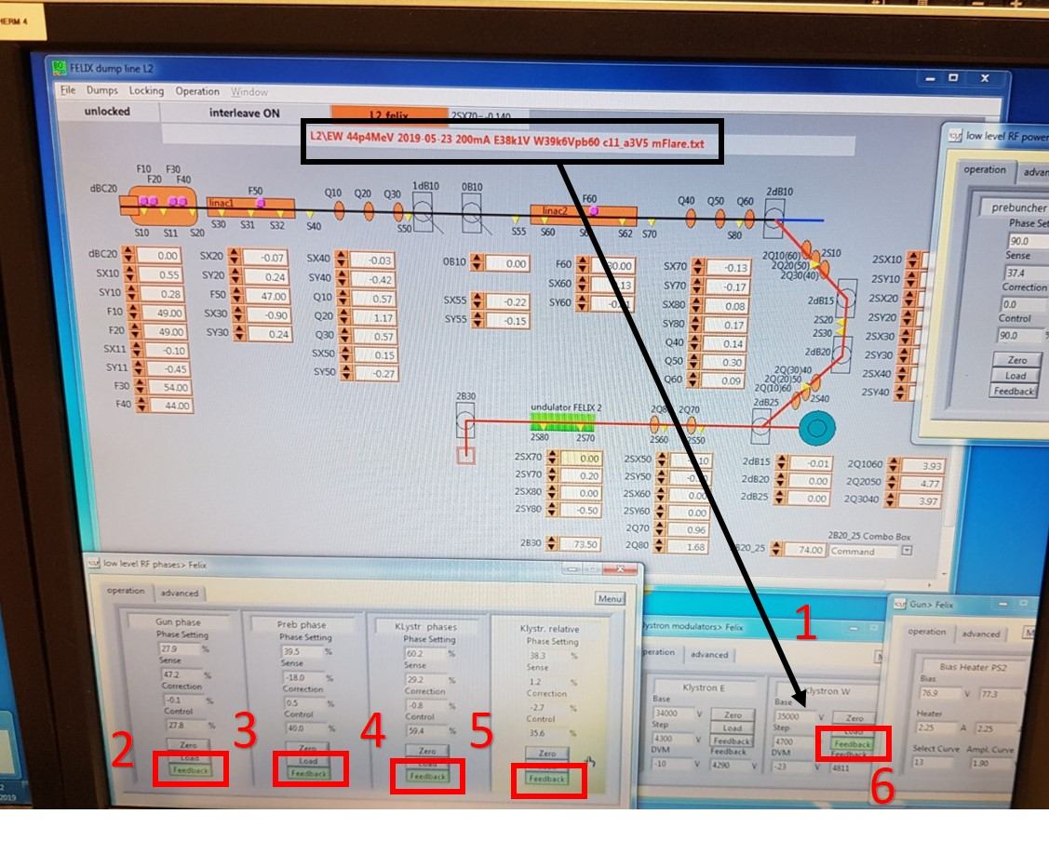
- In “Felix timers”, ensure (1) timer S1 is 2us, and (2) frequency divider is 10 (so 1Hz output).
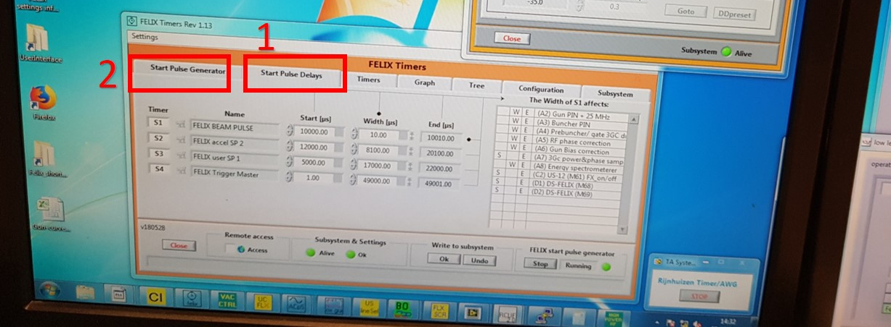

- Insert the beam splitter, and align the HeNe through the cavity mirrors. Watch “2S21” and adjust the downstream mirror. Watch “2S41”, and adjust the upstream mirror.
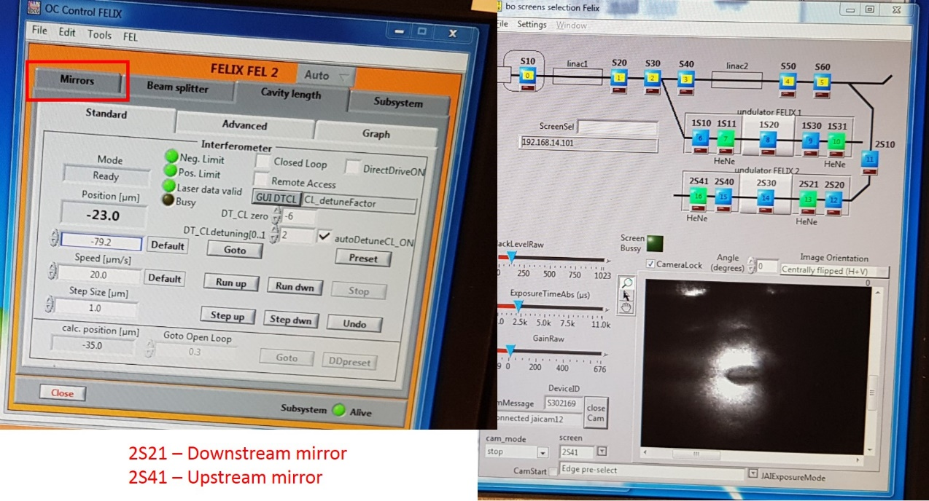
- Remove the beam splitter, and press the button “GUN RF timing on”.
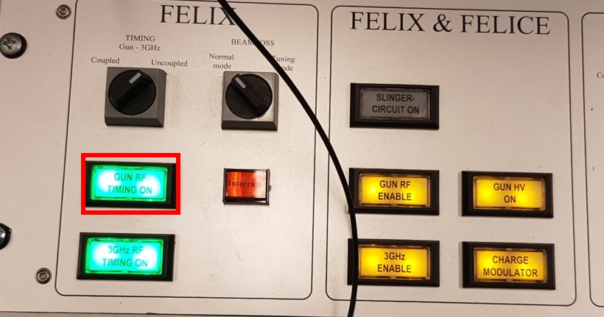

- Optimize the electron path. From the window “bo_gui_pm_main”, press the “PM” button, and match up the trace with the indictor on the left-hand scope. To do this, open the window “FELIX dump line L2”, and adjust the following elements:
PM | SX |  | Scope key  Yellow: “x-axis”  Blue: “y-axis”  Green: “…”  Purple: “…”
10 | 10
20 | 11
30* | 30
40 | 40
50 | 55
60 | 70
2PM30** | 2Q2040  2Q2050  2Q2060
* Fault here: align the blue channel (vertical alignment) one square below indicator
** For these, watch the height of the actual light
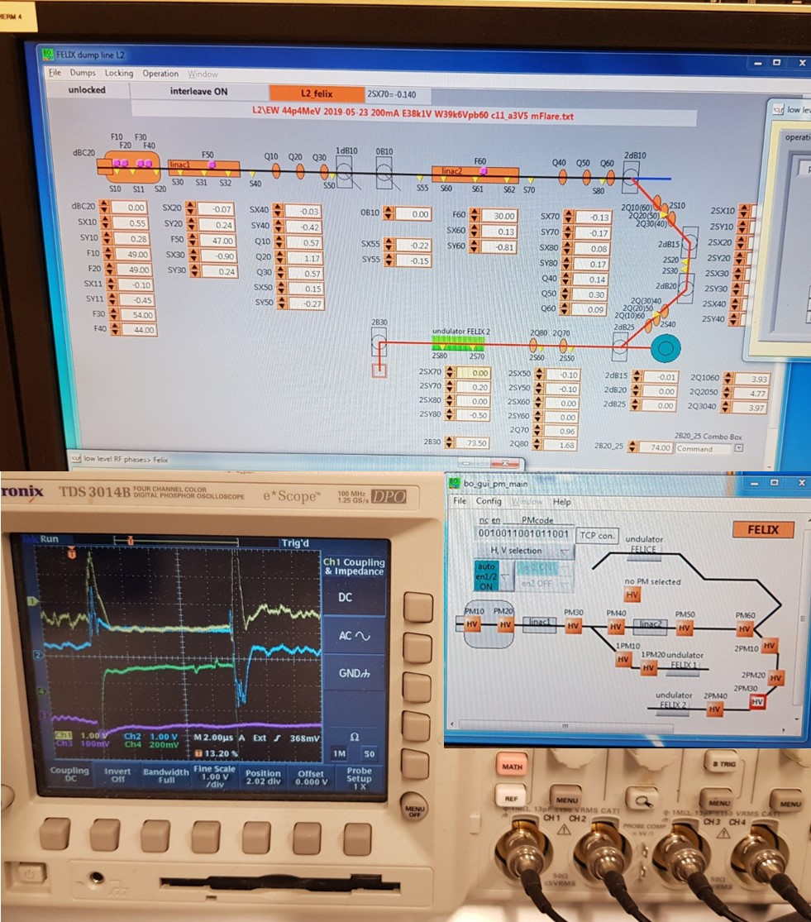
- In “Felix timers”, (1) change timer S1 to 10us, and (2) change frequency divider to 1 (so 10Hz output).
- In the window “Low level RF phases > Felix”, fine-tune the low-level RF phases. Set to zero if close to 10, and press “load” -> “feedback” on.
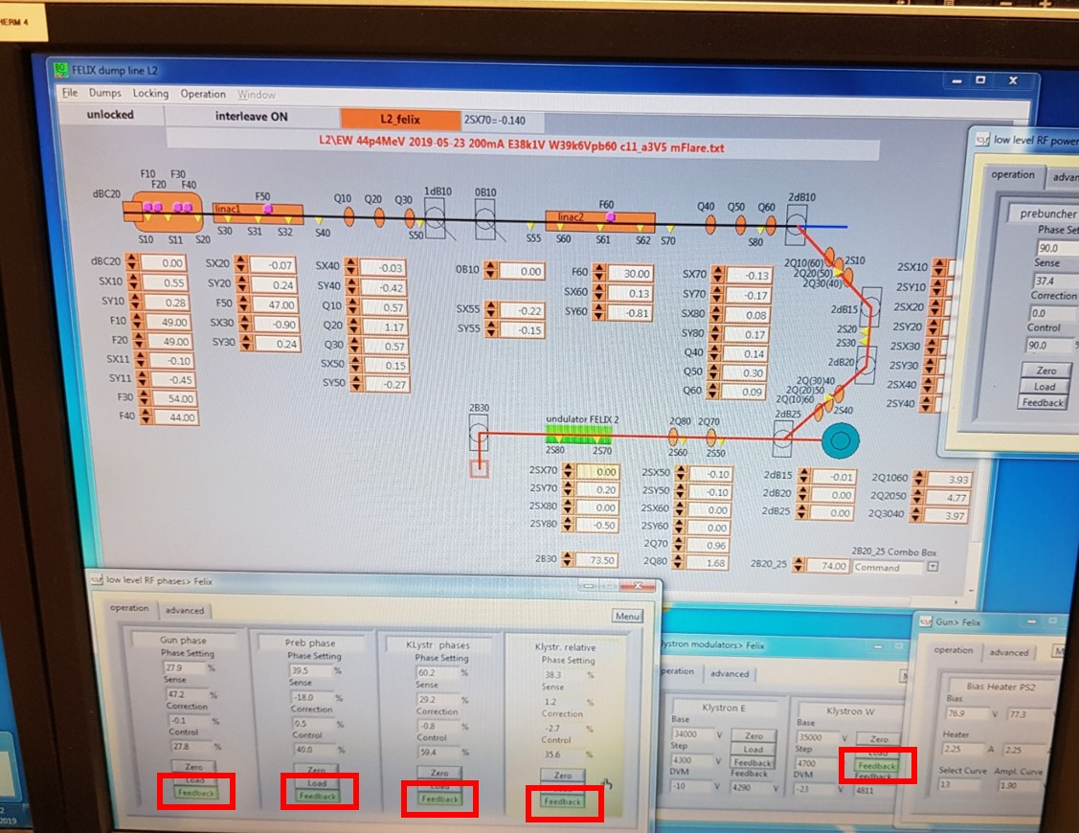

- In the window “Gun > Felix”, change “bias” to achieve ∼360mV (Ch1 on scope).
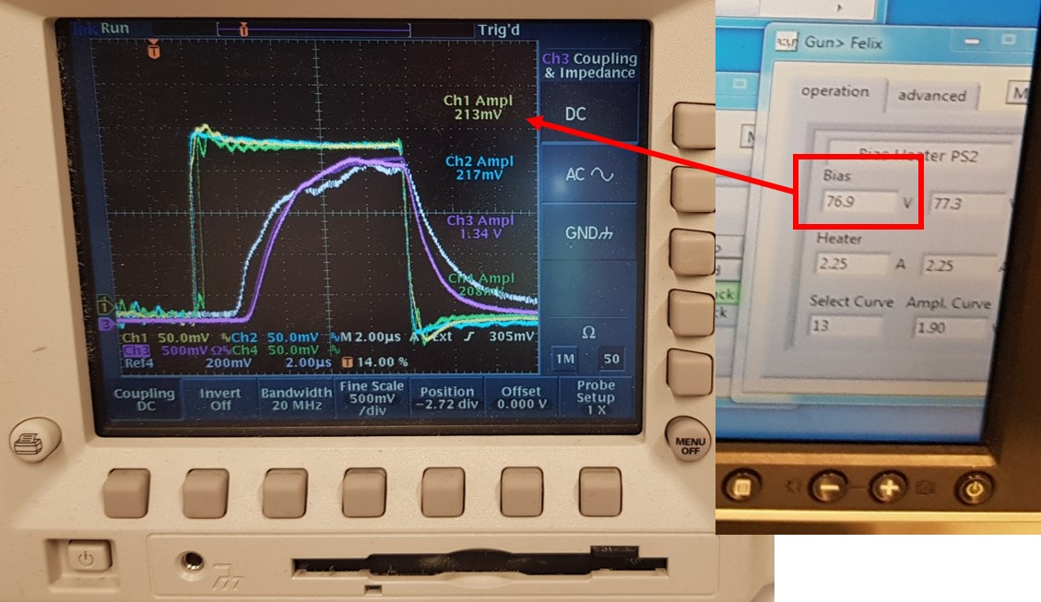
- Find cavity zero. In the window “OC Control FELIX”, set “dt_CL detuning” to 0, and change “DT_CL zero” in factors of 10. Optimize the height of Channel 1 only (it should be close to the unstable state). Then reset “DT_Cldetuning” to 1-2.
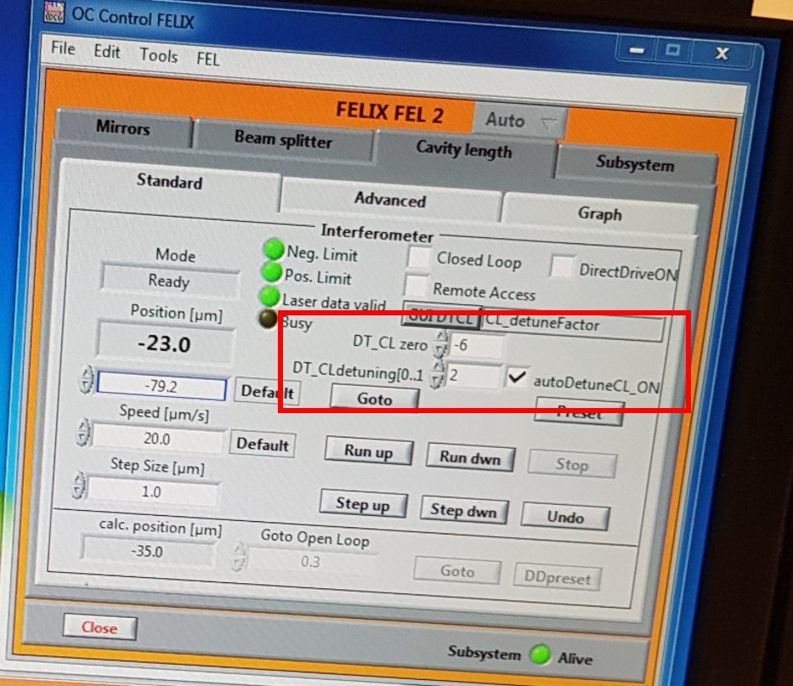

- Calibrate the wavelength. In the window “uc_flx_gui”, go to calc, and set the wavelength to the correct live value. Go to the diagnostic station, and flip the amplifier to x10.

Troubleshooting problems
- Problem: FELIX output goes off, and the usually-illuminated button “charge modulator” switches off.

Fix: Sometimes the heater for the klystron switches off. If you are quick, you can start it back up with no waiting time. Switch the button “GUN RF timing on” off, and enter the electronics room. Go to the heater (close to the end of the rack), and look at the relevant klystron.
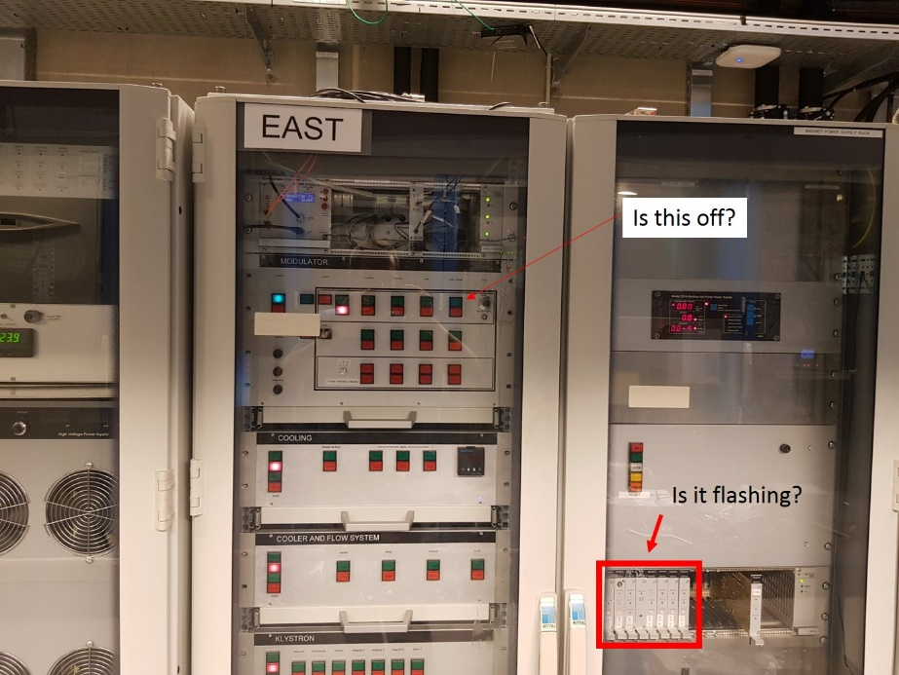
- If the light in “Delay switch” is blinking, take a pen, and press the red reset button. Leave the electronics room, and press “GUN RF timing on” back on. FELIX should now be running.
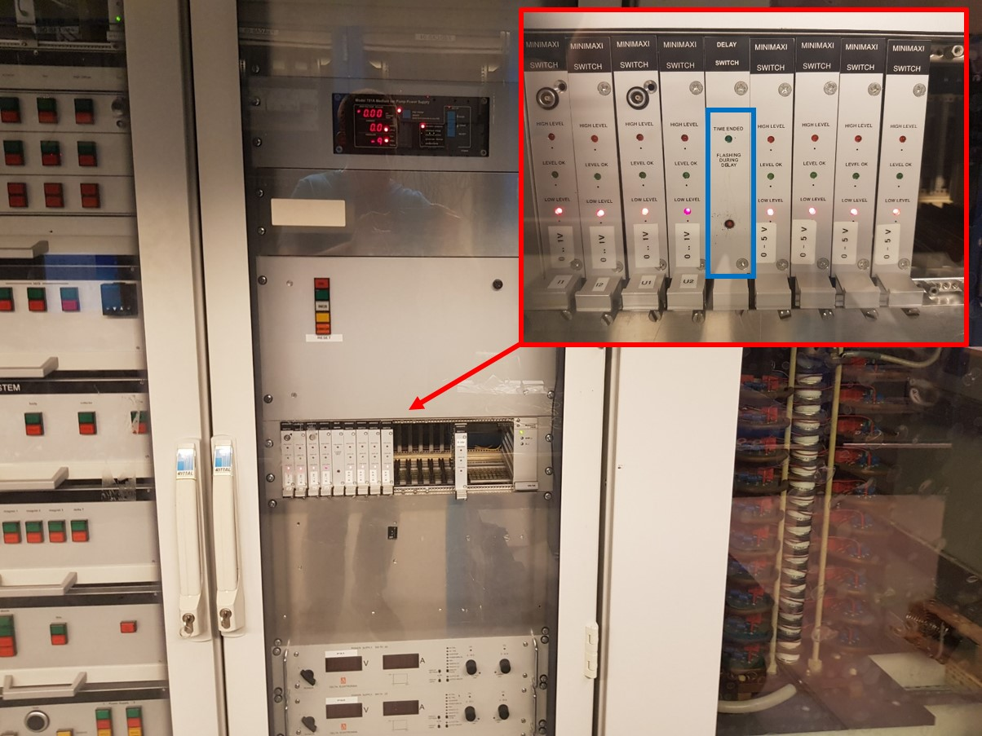
- If the light is not blinking, or you are have any doubts, switch the heating unit off and on. To do this, open the modulator system, and press “local”. Switch “high voltage” off, then the green button next to “mode” [latching everything on].
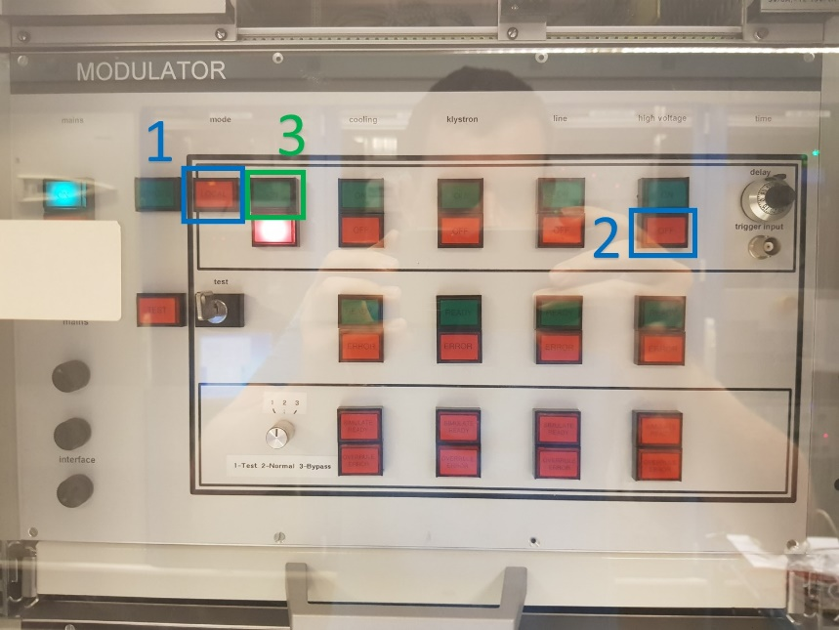
With this fix, you need to wait ∼30 minutes, until the klystron has reheated.

- Sometimes we want to use FELIX in 50 MHz mode. Ask the operators for permission to switch the trigger from 25MHz to 50MHz. This latch is located upstairs in the power-supply room, in one of the cabinets towards the end.

- Problem: If the FELIX output is going worse over time, but nothing is obviously wrong, it is fixed most easily by adjusting “Klystr phase” and Klystr relative”.

- Problem: The vacuum valves can occasionally shut – identify which valve is closed, and open it.
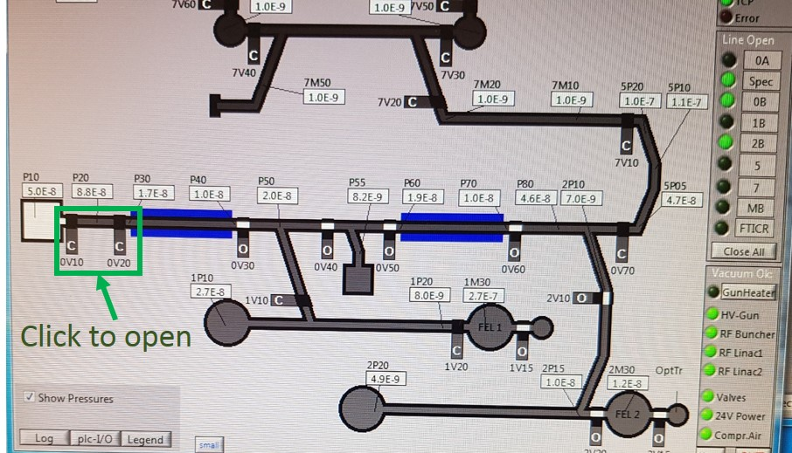

- Problem: FELIX light goes off, but all buttons on the main panel are still illuminated. One of the low level phase settings may have gone to 10%. The electron gun HV has dropped from -98 kV to about 0 V.
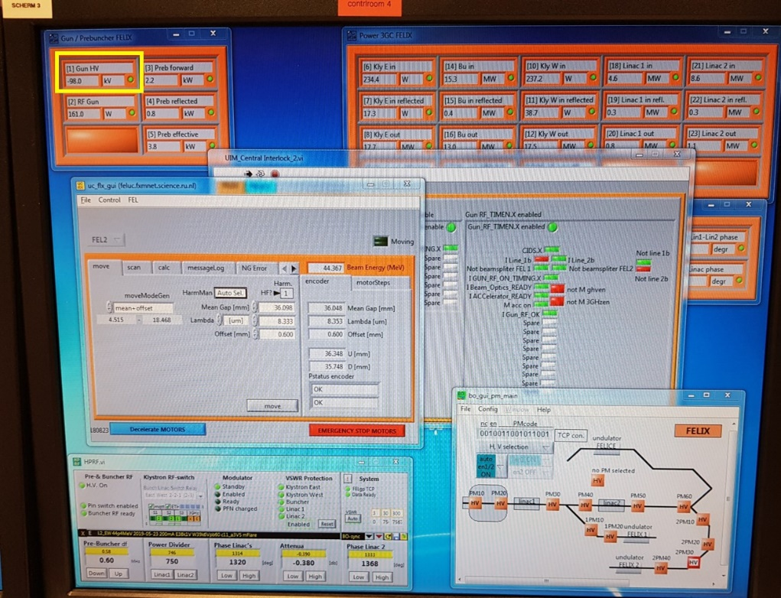

Fix: Switch the feedback of “low level RF phases” off, and press the “gun rf timing on” button off. Go to the electronics room, up the stairs, and go to the cupboard FF.09.
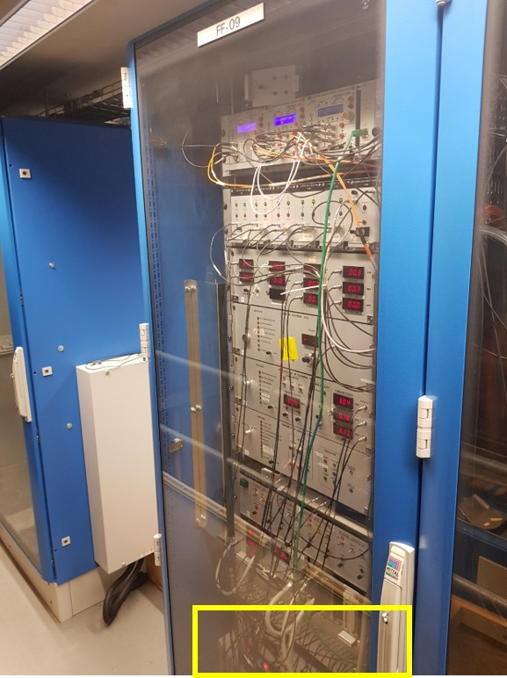
Check the current of the electron gun – it will (if this is indeed the fault) be 0A. Under the label “Crowbar”, there are two black buttons. Press both of these simultaneously, and the current should ramp back up.
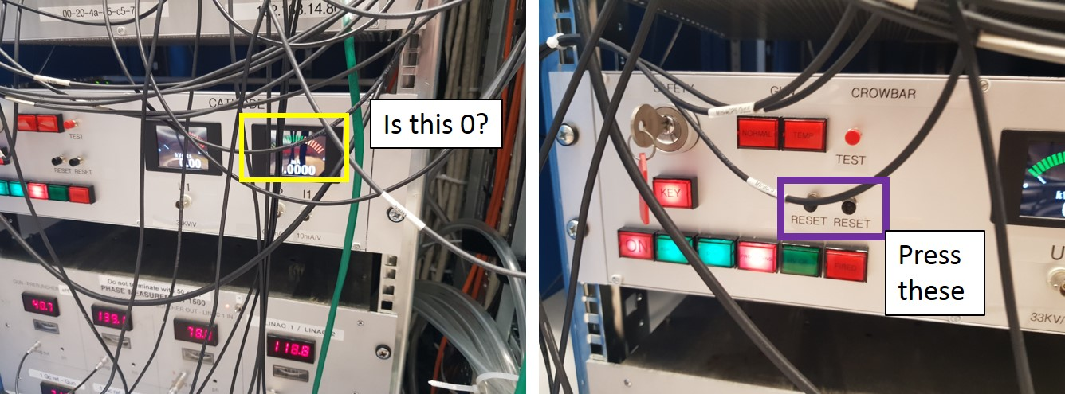
Go back to the control room, and double-check the vacuum valves are still open. Set the pulse timing to 1 µs, and check that the electrons are reaching the dump (i.e. press “gun rf timing on”). Slowly increase the timing back to 10 µs, checking that the electrons still reach the dump. If so, you should be able to see some weak IR light.

Optimize the phase settings, and once done, press “load” and “feedback. Find cavity zero again, and calibrate the wavelength.

