Shutdown FELIX

2022-12-01
Shutdown FELIX
- Go to the control room to the FELIX operating post.
- Turn off the GUN RF TIMING ON button, turn the BEAMLOSS knob to Normal mode, Switch off 3GHZ RF TIMING ON, GUN HV ON, GUN RF ENABLE, 3 GHZ ENABLE, CHARGE MODULATOR and SLINGERCIRCUIT ON. 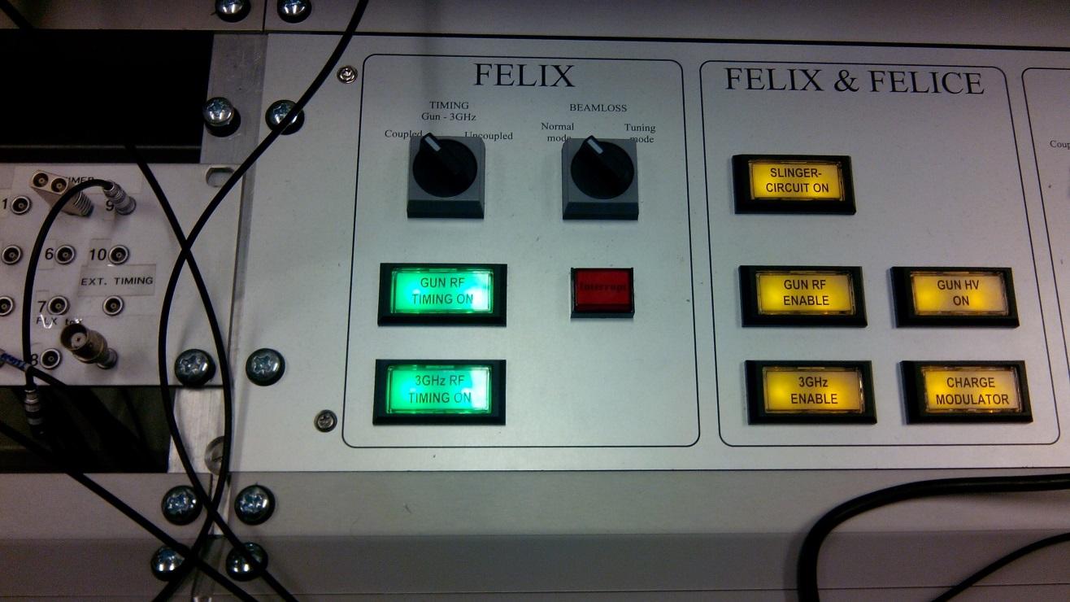
2b
2e
2f
2g
2h
2d
2c
2a

- Turn off all the Feedback buttons.
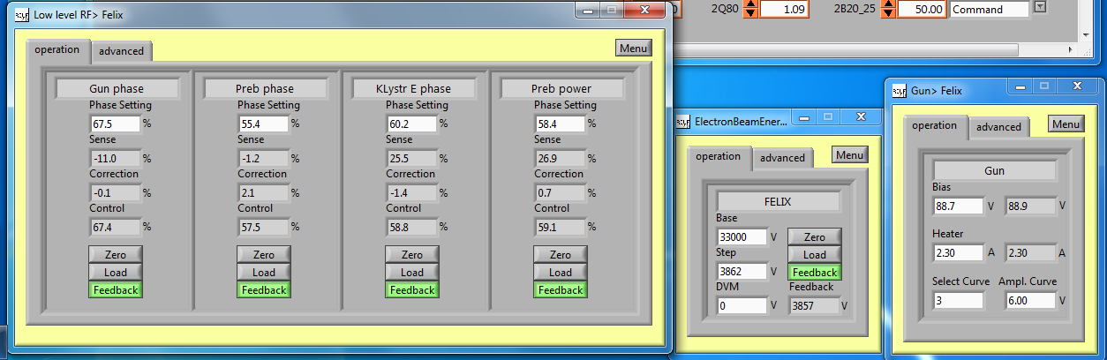
3

- Next is to turn off the dipoles via the controlroom PC. Search for the program FELIX dump line L2.Click on the arrow near the command box and chose: Mains power off.
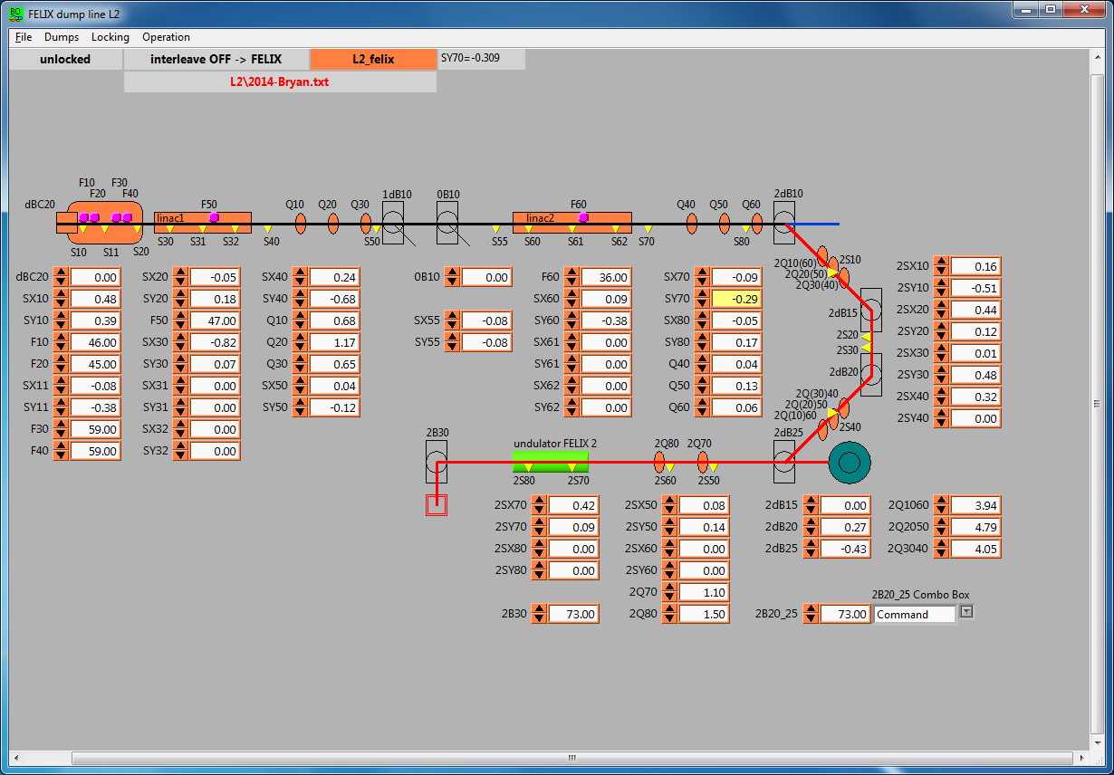
4

- Next is to close all vacuum valves by pressing the close button in the Vacuum Control Gui. All valves should close (display the letter C) and the whole beamline should be gray.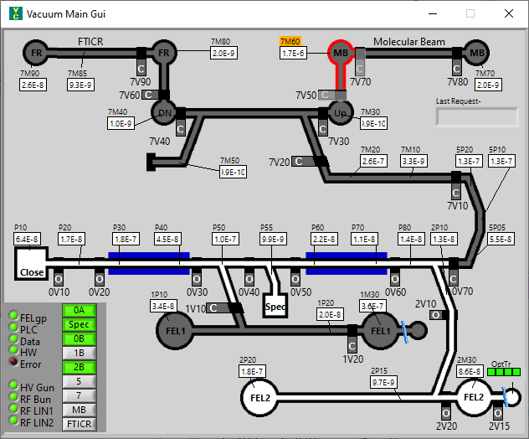
5

- The next step is to make shorter pulses in the timing system gui. By making it 2.00 us and pushing Ok afterwards.
7b
7a
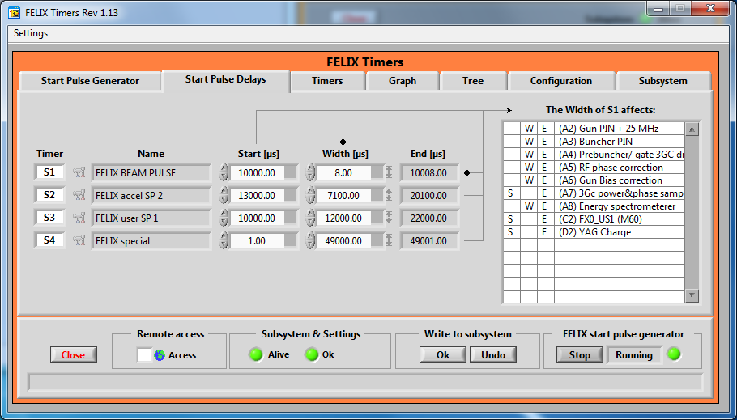

- Now it is time to decrease the repetition rate of FELIX on the tab Start Pulse generator, put the clock divider to 10 and push Ok again.
8b
8a
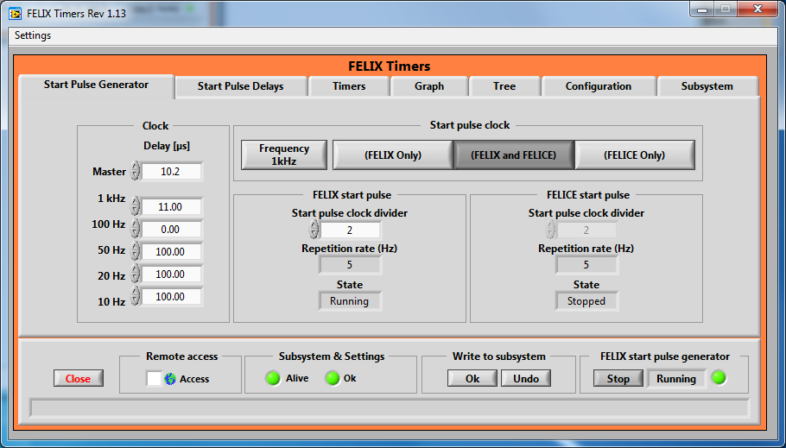
- The next step is to check if the RSS is in <Restricted access> if not put it in the correct access mode. Head downstairs into the FEL Technical area, and go to the modulators cabinets, which are located near the FELIX klystrons.
- Next is to turn off the RF amplifier from the WEST modulator. It is hanging on the left wall when you enter the FEL Technical Area.
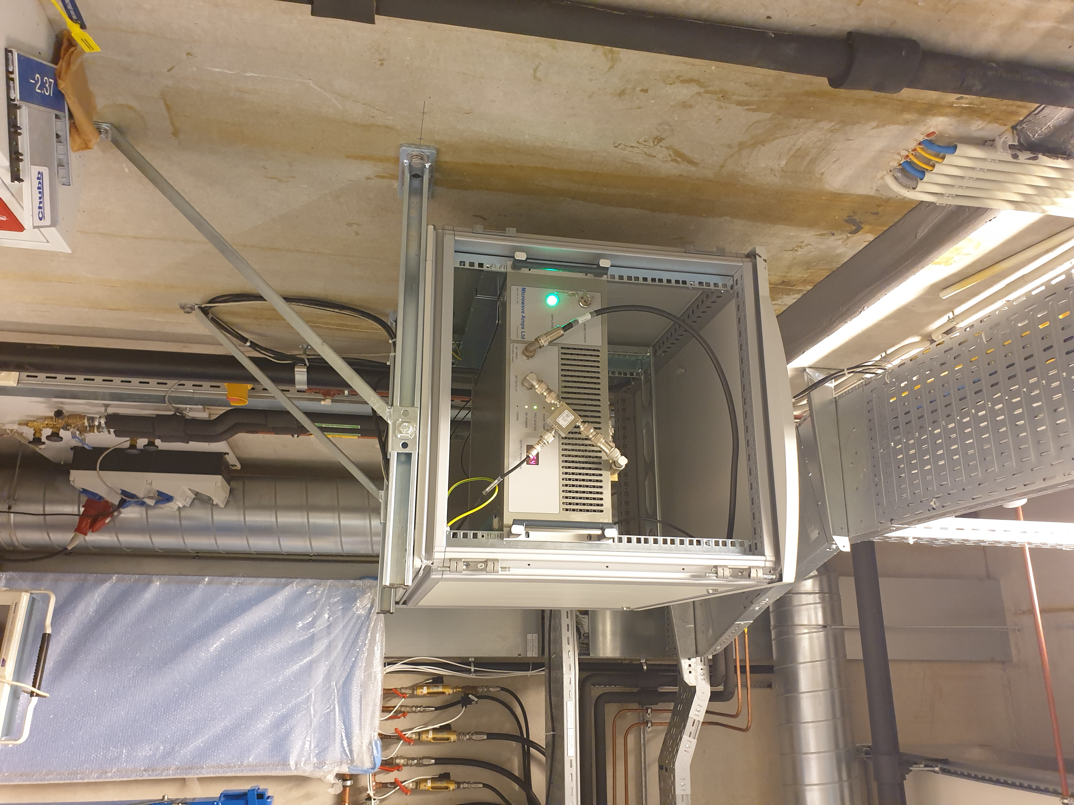
10

11
- Put the 2 modulators into local control by pushing the red local button.
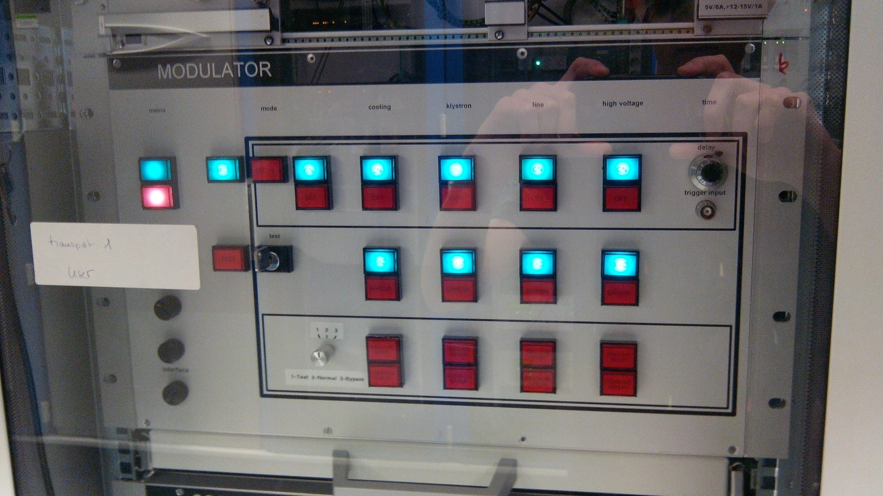
12c
12e
12d
12b
12a
- Next when the controlmode is set to local control is to switch of the following parts in that order: high voltage, line, klystron, cooling and mode by pushing the buttons.
- Next turn off the 4 high voltage power supplies which are located next to the klystrons. Use the main switch not the key
12
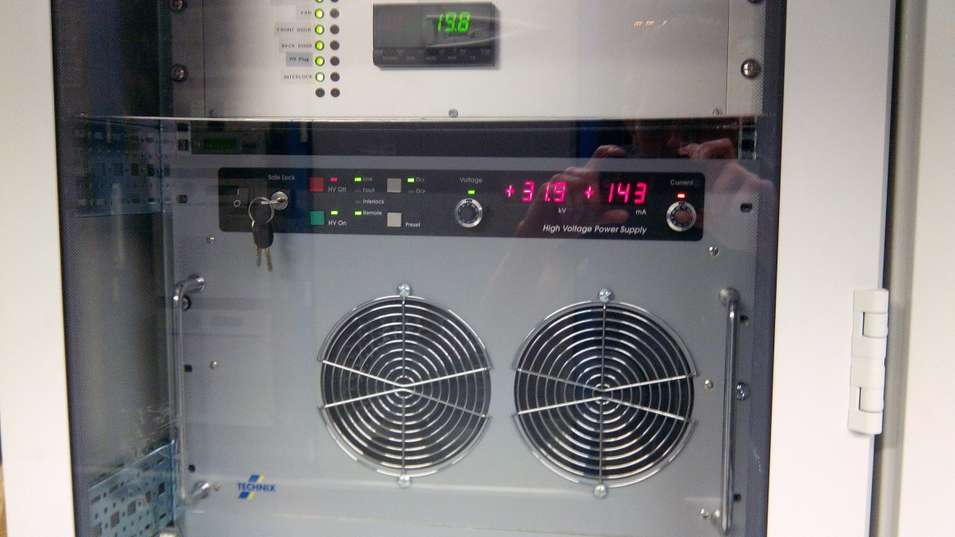
- As next step it is time to turn off the RF amplifier and Gun High voltage power supply, which are located at the right backside of the FELIX klystron, turn off the green amplifier enable button, and turn off the high voltage power supply.
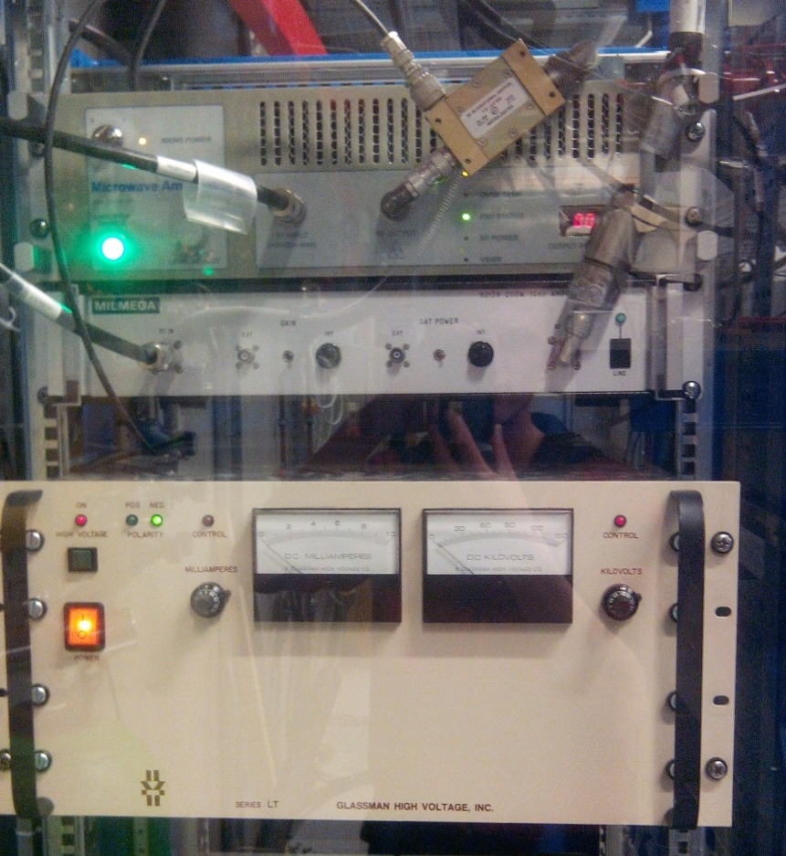
13b
13a

- As next step the cavity amplifiers have to be shut off, this is done with the COFFEE interface. Push both red buttons.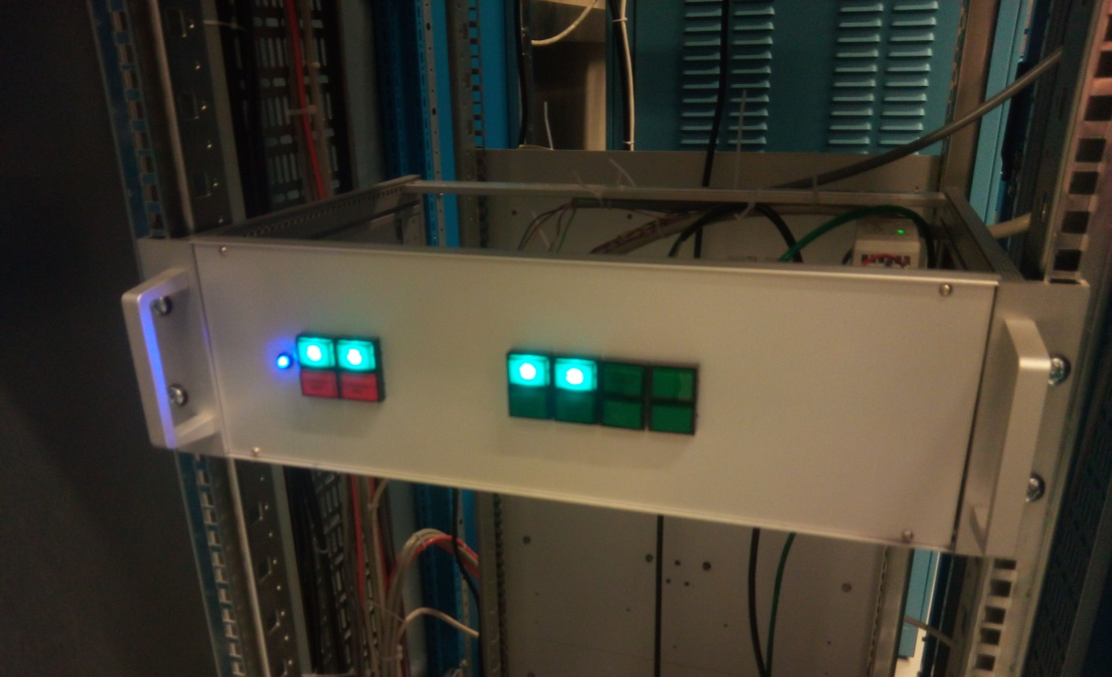
14
IF FLARE is running proceed to step 23.
As last and final step is to put off the power supplies of the electronics cabinets, this panel is located at the entrance of the FEL technical area, next to the electronics corridor, turn off all the green buttons. Be sure FLARE isn’t running, because this action will pull away the FLARE electron beam.
- Next turn off all the cabinets of FELIX, by turning all the green lights off.
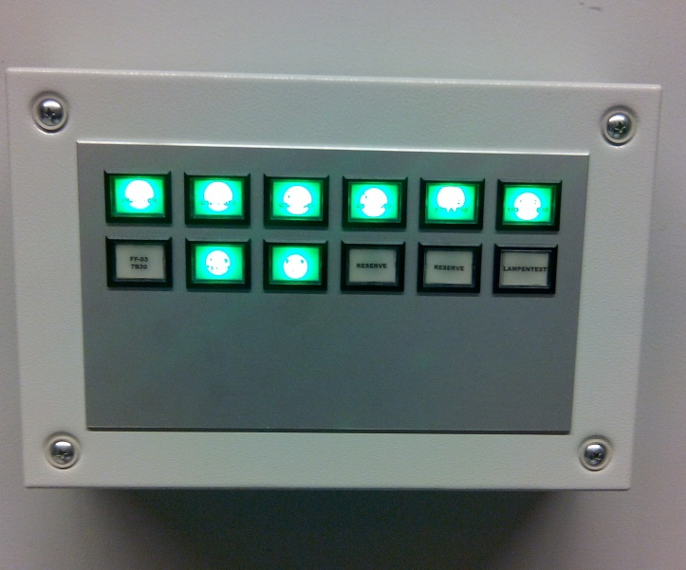
15

- Go back to the FELIX Console and open the FLARE Solenoids program. Of it is not already open you can open it from the FELIX Shortcuts folder on the desktop. 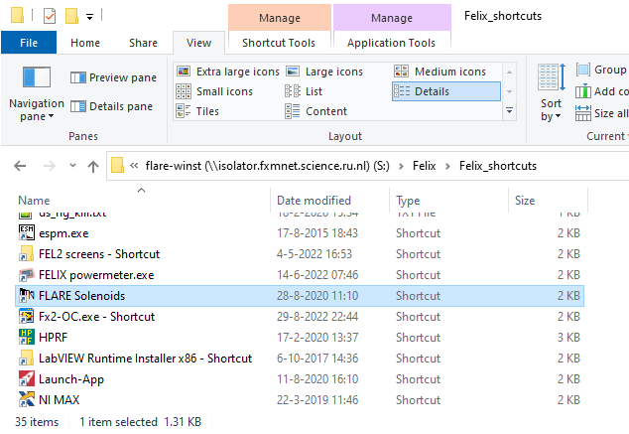
16
- Push “Request master” and then “Turn off solenoids”. The green magnet indicators should all turn dark red to indicate they are off. If the solenoids are already red (as in this screenshot) then this step is already done.
16
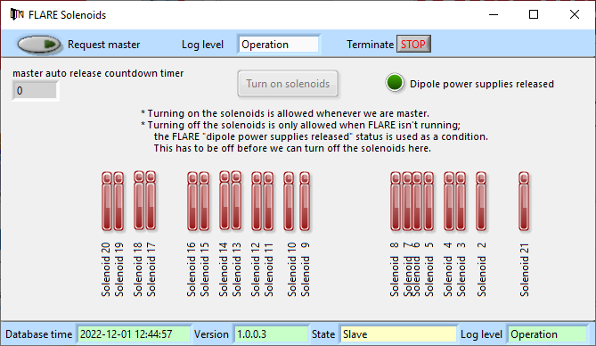
17

- Last step is to turn the Masterkey from RUN to SWEEP.
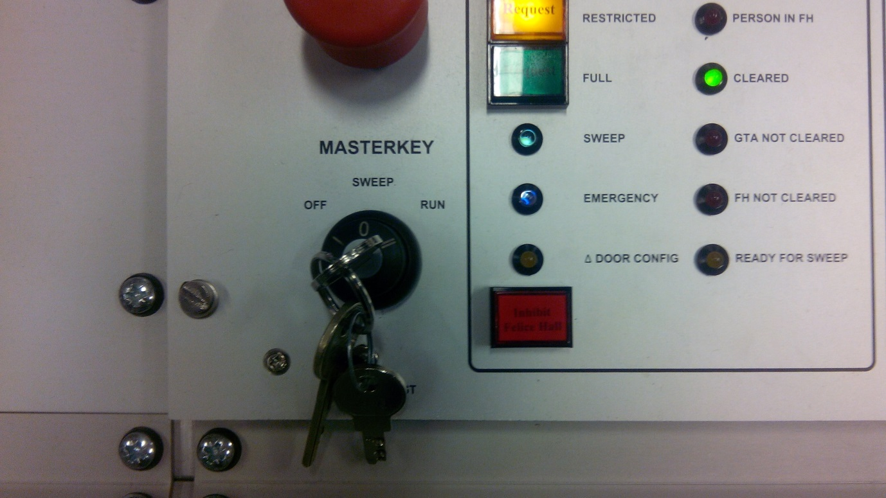
23

- Shutting down has now been completed.

Changelog
2022-12-01 VIC | Vacuum GUI screenshot aangepast  COFFEE interface, beide knoppen rood  FLARE solenoids interface aangepast

